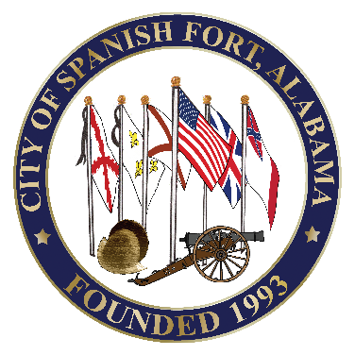
CITY OF SPANISH FORT
7361 Spanish Fort Blvd.
Spanish Fort, Alabama 36527
(251) 626-4884
(251) 626-4880 Fax

City Council

William A. Menas, Sr.
Robert Curtis Smith
Bobby J. Fortenberry
Clewis W. Smith, Jr.
Mary W. Brabner
Michael M. McMillan
Mayor
Mary Lynn Williams
City Clerk/Treasurer
“A City of Spirit”

MEETING NOTICE

SPECIAL CITY COUNCIL MEETING

Monday, August 10, 2020

5:00 p.m.

Meeting will be held
at
Spanish Fort Community Center
7361 Spanish Fort Boulevard

